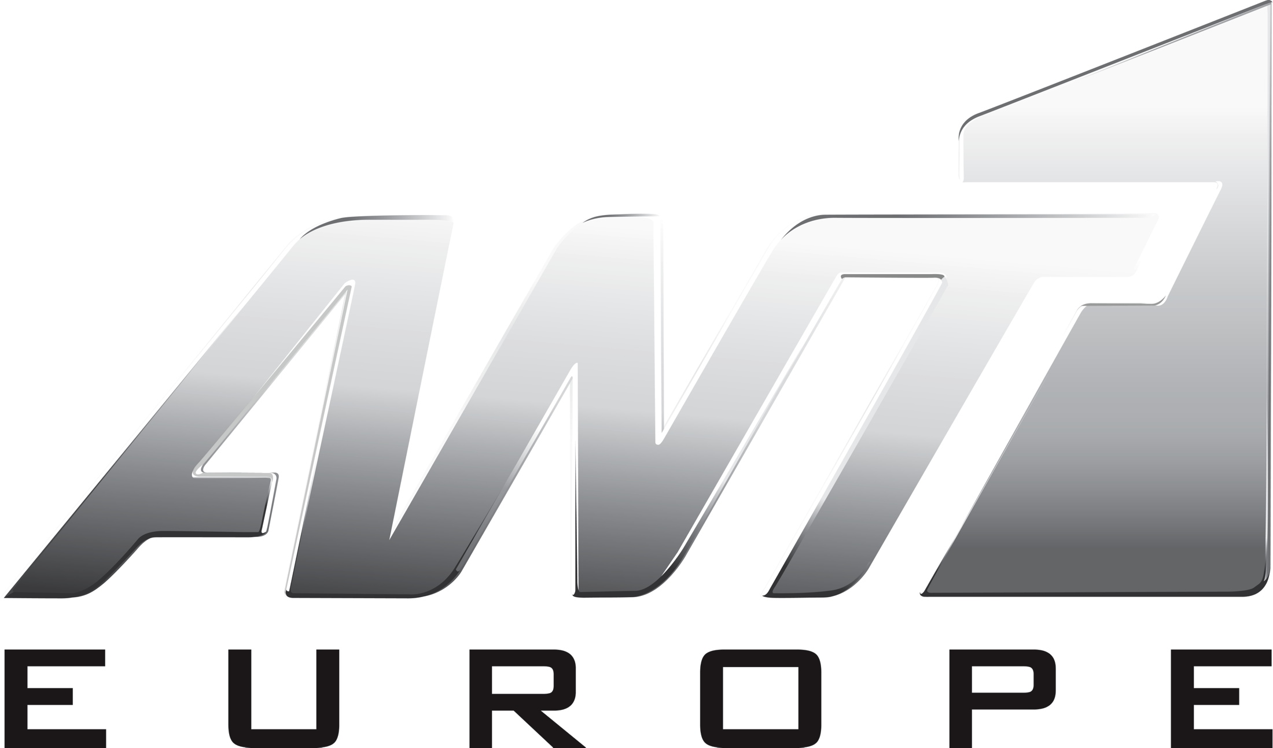

ANT1 Europe now available to over 8.5 million households in Germany through

Kabel Deutschland
Antenna Group concluded a very important agreement with Kabel Deutschland to expand the International distribution of ANT1 Europe, in the German market through its largest cable platform, Kabel Deutschland.
ANT1 Europe is now available to over 15.5 million households in Germany for only 2,90 € per month, giving the opportunity to all Greeks who live in Germany to enjoy its programming and to essentially shorten the distance between them and their homeland.
ANT1 Europe features the content of Antenna TV, the leading Greek television network. The channel is broadcasted live, 24-hours direct from Greece and features live news, premium shows and series, Greek movies, shows, music programs, sports and much more..
Antenna Group is the leading Greek Media Group. The company owns and operates ANT1 TV, which is the leading television broadcast network and producer of television programming in Greece and the Greek speaking world. Antenna Pay TV operates and distributes the Channel internationally in the US, Canada, Australia and throughout Europe in more than 44 countries.
To learn more about Kabel Deutschland or to add ANT1 Europe, customers can visit, www.kabeldeutschland.de. For more information regading ANT1 Europe, please visit, www.antenna.gr/europe.

